Sample Letter of Good Standing From Employee

January 19, 2019

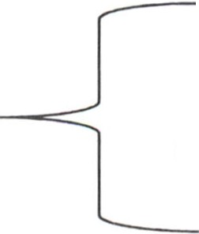

Employee Information

John Doe

123 Drury Lane

Required Information Jacksonville, NC 28540

910-456-7890

Dear Approving Official at MCB Camp Lejeune, NC,

My name is John Doe, and I am respectfully requesting access to MCB Camp Lejeune to do work for my company, Smith Welding.

On January 1, 2014, when I was 19, I was arrested for getting into a fight with my friend outside his residence in Kinston, NC. At the time of arrest I was impaired by drugs and had paraphernalia in my possession. On June 1, 2014, the judge convicted me of felony assault and possession of drug paraphernalia. After my conviction, I was fined and ordered to attend drug and alcohol counseling, as well as anger management, which was completed on December 20, 2014. Since then I have been clean of drugs and have volunteered at my church for the past three years.

I have been an employee at Smith Welding for six months. I depend on this job to support my two kids and wife. I understand the mistakes that I made when I was younger and have worked to improve myself to be a better example to my children. I sincerely hope you can look over my past misgivings and consider me for access to the installation.

Sincerely,

John Doe

910-456-7890

\*Note: Letter must include individual's contact information and company name. Explanation of conviction information/circumstances and steps individual has taken to improve themselves are also required if applicable.

**\*\*\*This is a sample letter only. Including the information depicted above WILL NOT guarantee an appeal approval\*\*\***